Test Cases:

Test Case # 1: Add User Button Works

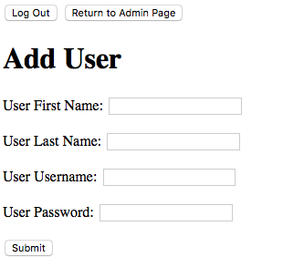

Test Case # 2: View Course Button Works

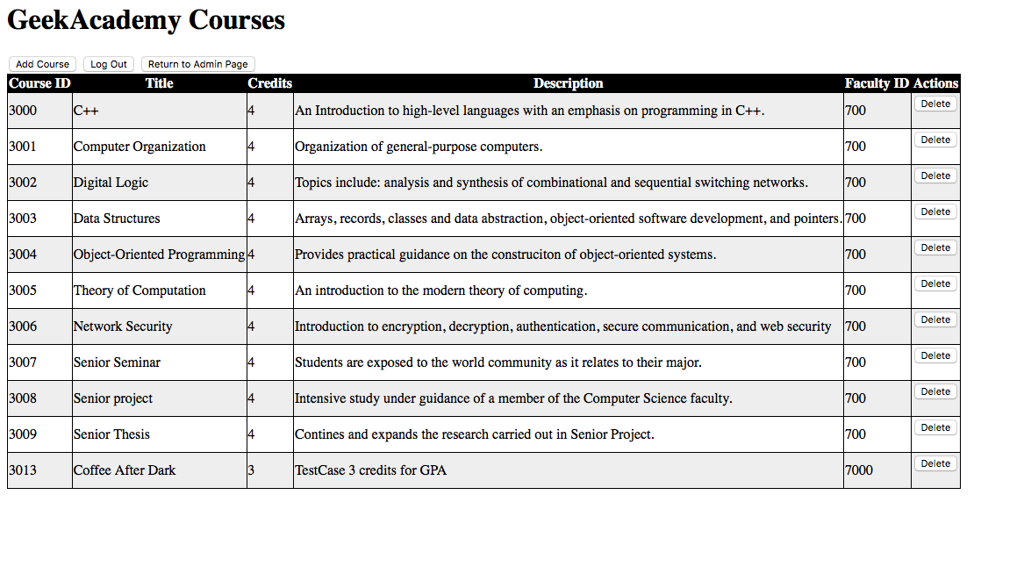

Test Case # 3: View Schedule Button Works

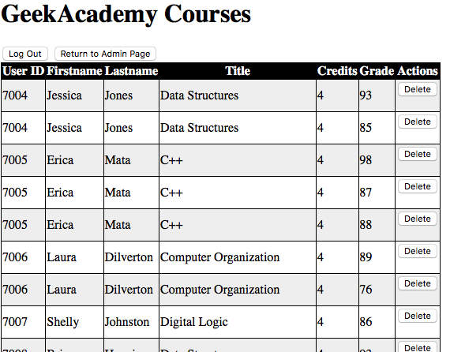

Test Case # 4: Add Grade Button Works

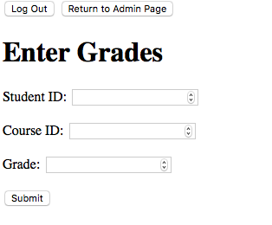

Test Case # 5: Test Case # 5: Log Out Button Works

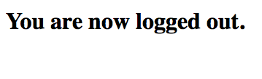

Test Case # 6: Return to Admin Page Button Works

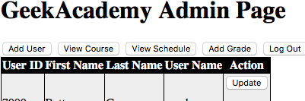

Test Case # 7: Update Button Works

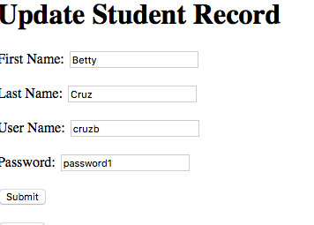

Test Case # 8: Cancel Button on Update Works (returns to Admin Page)



Test Case # 9: Delete User Button Work

Before clicking delete:

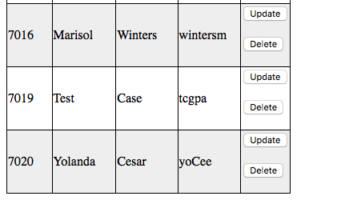

After Clicking Delete:

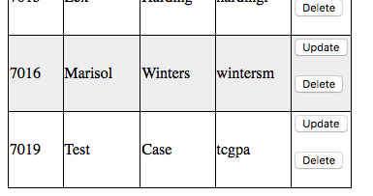

Test Case # 10: Delete Button on View Schedule Works*

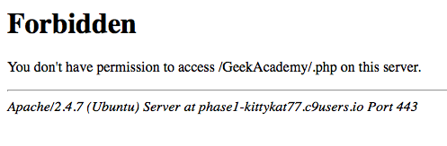

student_schedule assists View Schedule to populate information, but the student_schedule is not properly linked to the database via mysql.

***\*Note to professor on Test Case Issues explains the problem.***

Test Case # 11: Login Screen Appears

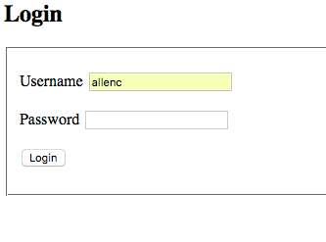

Test Case # 12: GPA Button Works

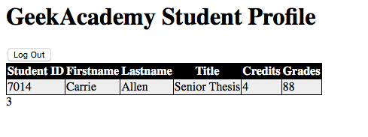

Test Case # 13: LogOn Link on Log-Out Page Works

Before Clicking Link:



After Clicking Link:

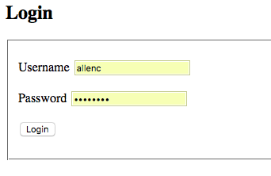

Test Case # 14:. LogOff Link on Log-Out Page Works **

Before Clicking Link:



After Clicking LogOff Link:



**Issue, the link logon directs the user to the logon page instead of exiting the system.